

MD.Razia
M. Adith Kumar Reddy
2520030559
CSE
Co-3

Case Study topic: HealthNet Hospital Network Optimization using Minimum Spanning Tree (MST)

Work Done Summary:
In this case study, we implemented an Electric Power Grid Optimization System using the Minimum Spanning Tree (MST) concept. Power stations are represented as graph vertices, and transmission lines are represented as weighted edges. Kruskal's Algorithm was used to connect all power stations with the minimum installation cost while avoiding cycles. The MST ensures an optimized and cost-effective power distribution network.

Implementation Details:
- Represented power stations as graph vertices.
- Represented transmission lines as weighted edges.
- Applied Kruskal's Algorithm to construct the MST.
- Sorted edges based on transmission cost.
- Used Union-Find for cycle detection.
- Connected all power stations with minimum cost.
- Calculated the total optimized network cost.

Results and Screenshots:

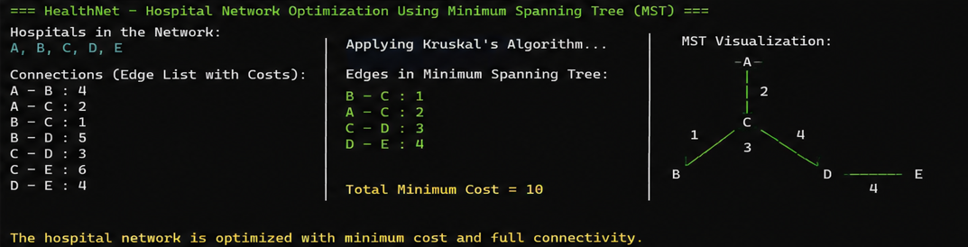
The HealthNet Hospital Network Optimization System was successfully implemented using Kruskal’s Minimum Spanning Tree algorithm. Hospitals were connected through an optimized communication network with minimum infrastructure cost while avoiding redundant links. The final MST achieved efficient connectivity among all healthcare centers. Screenshots demonstrate graph construction, MST generation, and optimized network cost calculation.
The Electric Power Grid Optimization System was successfully implemented using Kruskal's Minimum Spanning Tree algorithm. The MST connected all power stations with the minimum transmission cost while avoiding cycles. The optimized network achieved a minimum total cost of 9 units.

GitHub Link: https://github.com/Adith471/DSA-2/tree/main

